SEO IN 2020
“SEO DOC FOR BEGINER TO ADVANCED”

- Find Our Web Site Niche.
- Our niche is not difficult to rank our website on search engine so please find a proper easy niche for fast ranking.
- Proper Keyword Research.
- Tools
    - ahref.com Or ubersuggest.com
    - Keyword Everywhere - extension for chrome browser.
    - Kwfinder.com
    - Moze
    - Buzzstream
    - Google [ find search related top keyword ].
    - YouTube [ Find Keyword And Related Keyword ].
    - Keyworddit [ Find Keyword In Reddit.com ].
    - Google Trends.
    - ExplodingTopics.com
    - Keyword Research
    - Semrush
    - CanlRank [ Best Tool For Site Rank ].
    - Google Search Console.
    - LSI Graph [ These Tool Are Used To Find Great LSI Keyword To Rank Site Higher ].
- Always Use High CTR Keyword.
- Use Another Related Keyword In Our Article.
- Don’t Try to use keyword which is already high ranked by authorized site.
- Use Keyword which have less than 20 SEO difficulty [SD ,PD]
- Use [ Find ] Top 3 Ranking Web Site Keyword For Our Article.
- Long Tail V/S Short Tail Keyword [ Use Both Of Them For Batter SEO Rank ].
- Mostly Use Long Tail keyword.
    - Short Tail Ex :- Digital Marketing
    - Long Tail Ex :- Digital Marketing Free Course In 2020
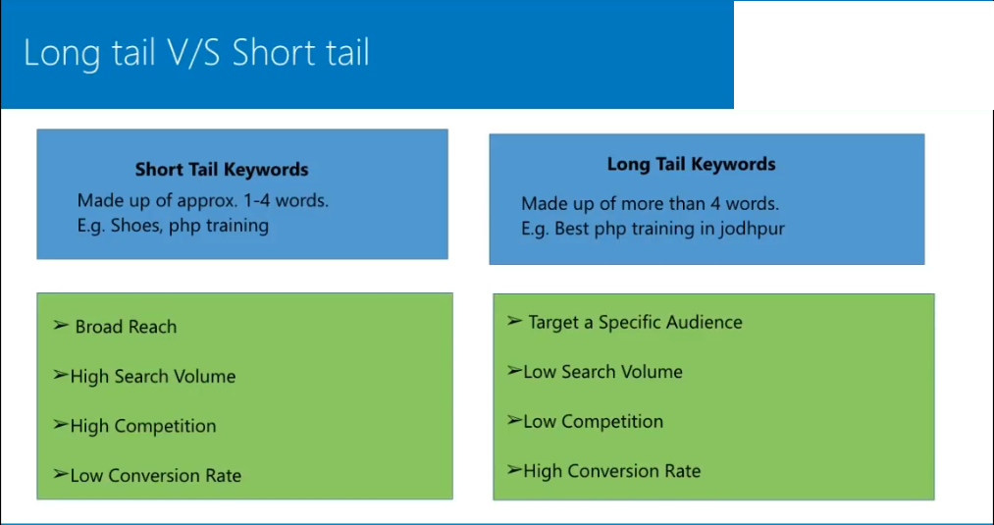
- ON Page SEO

- Write SEO Friendly Article.
- No Grammatical Error.Check Grammar Error By grammarly.com
- Quality Of Article [ User Friendly Article ].
- Use Interactive Element [ Like Pictures And Videos ].
- Write Info graphic based Article.
- Article Length Is 25 Line And 3000-4000 words Approximate.
- Write SEO Friendly Meta Description [Meta Description Increase CTR Rank].
- Use Up to 20 Different keyword And One Main keyword In Article. Always Highlight All The keyword In Article.
- Use Main Keyword On Article Title , Meta Title And Description.
- For Affiliate Web Site Article Use Date Time And Coupon And Review In Our Article Title And Description.
- Write Effective [ Attractive ] Description.
- Before Written Article Proper Research To Our Competitor Web Site Article.
- Write Main Keyword In image Alt Tag Always.
- Always Use Main Keyword In Bold and Highlighted On Our Article And Also Use [“ ”] Or Under Line For Main Keyword In Article.
- Use Proper heading tag.
- Use Internal Linking In Another Related Article In Our Web Site.
- Always Write Comprehensive Article.
- Use Date In Our Article URL And Title As Soon As Possible.
- Always Update Your Web Site Article [ Content ] Continually For Latest information.
- Use Compressed image in our Article by compressjpeg.com
- Use up to 7-10 images In our affiliate Web-Site Article.
- Proper Formatting Article.
- Increase Our User Signal Means User Interaction In Article There Are Two Factor 1. Bounce rate And 2.Time Spent On The Article.
- Use Google Webmaster tool to find the high impression keyword in our web site and use this keyword to create a new SEO friendly article in 300-500 words.
- CopyScape.com [ Use To Find Duplicate Content On Internet].
- Hashtagify.me [ find popular hashtag for your youtube videos and article].
- Use Paid Content Writer Web Site Like iwriter.com
- ClickToTweet.com [ Use to promote our site on twitter ].
- More Traffic By Content Transformation [ Convert One Of Our Web Site Blog To YouTube video other to get more traffic.
- Use Podcast.
- Use Content Relaunch Strategy.
- Create A Content That Appeals to influence.
- Add Share Button On Our Article.
- Tag Optimization -
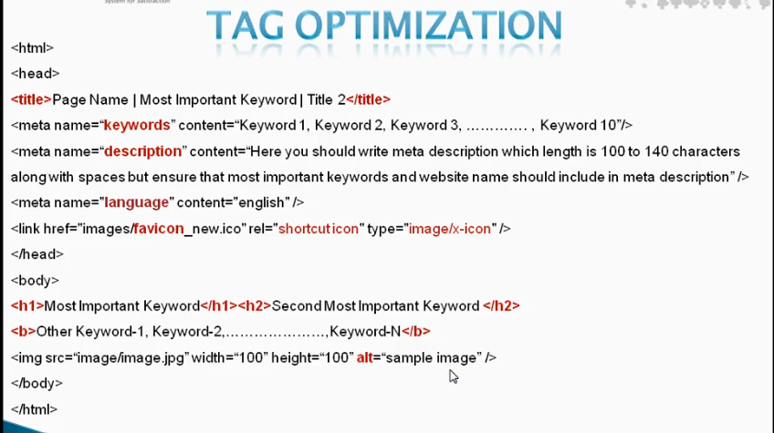
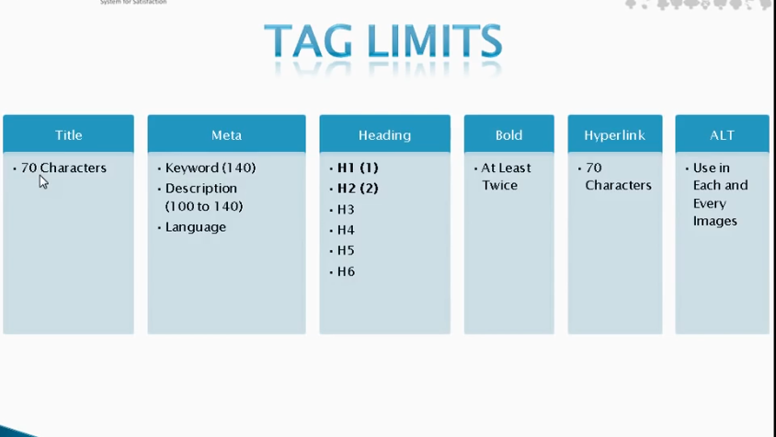
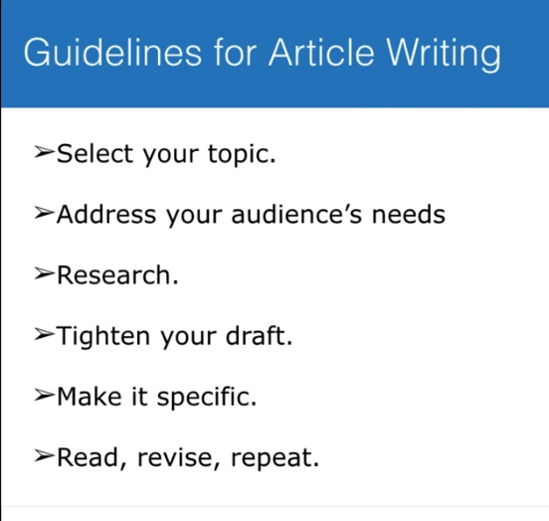
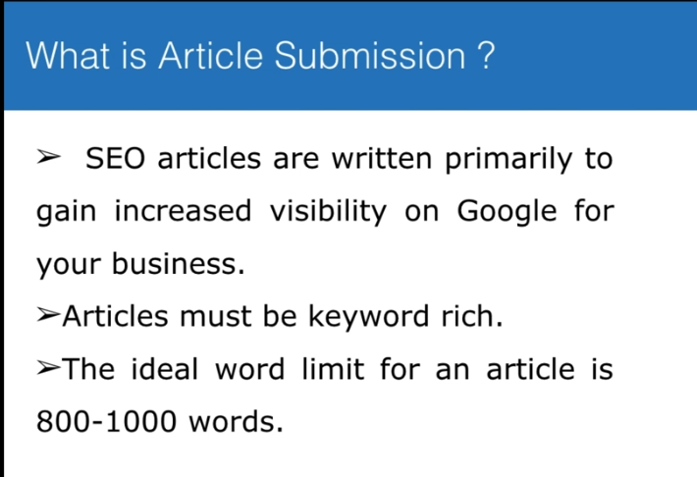
- Use PDF Submission Web Site To Submit Our Article PDF.To Increase Our SEO Rank.
- Always Check Our Competitor Web Site And There Article For Latest Update Through Google Alert.
- Google Alert For Monitor Your Competitor.
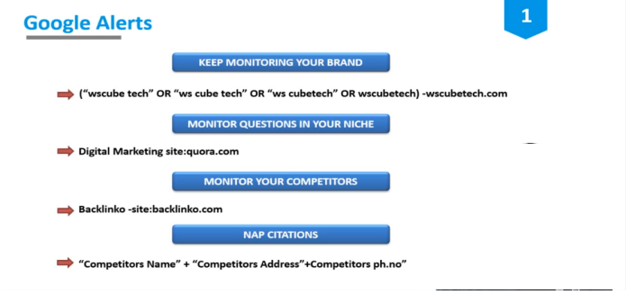

- SEO Friendly Web Site Design.
- Build Your Brand.
- Target Your Site To Rank On First 3 Result.
- Check Your Web Site On backlinko.com Or google-ranking-factor
- Use White Hat SEO [ Preferable ].
- Black Hat SEO [ Only For Some Case ]. Ex - Movies Web Site.
- Test Your Web Site Page Speed On Google.
- Website Load Time.
      - Best - Under 3 Second.
      - Average - Under 7 Second
      - Low - 8 To Above
- Implement SEO In Practical.
- Use only relevant black-ling.
- Check SEO Audit In Every 30 Days.
- For Web Site SEO Audit Tools =>
- ahref.com [ Paid ].
- screamingfrog.co.uk [ Free With Trail ].
- ubersuggest.com [Free].
- Semrush.com [Paid].
- Moze [Free].
- Buzzstream [Free].
- SimilerWeb [Free].
- Check Our Web Site Alexa Rank
        - Alexa Rank Is Low = Batter
        - Alexa Rank Is High = Not Good

- Quicksprout.com [ for website audit free ]
- WebSite Responsive.com [ csschopper.com].
- Google speed insight. [ Page Speed Checker Free ]
- Google Search Console [ Analyse And Use For More Engagement ].
- Google Trends. [ for website audit free ]
- Woorank.com [ for website audit free ]
- Smallseotool.com [ for website audit free ]
- Seositecheckup.com [ for website audit free ].
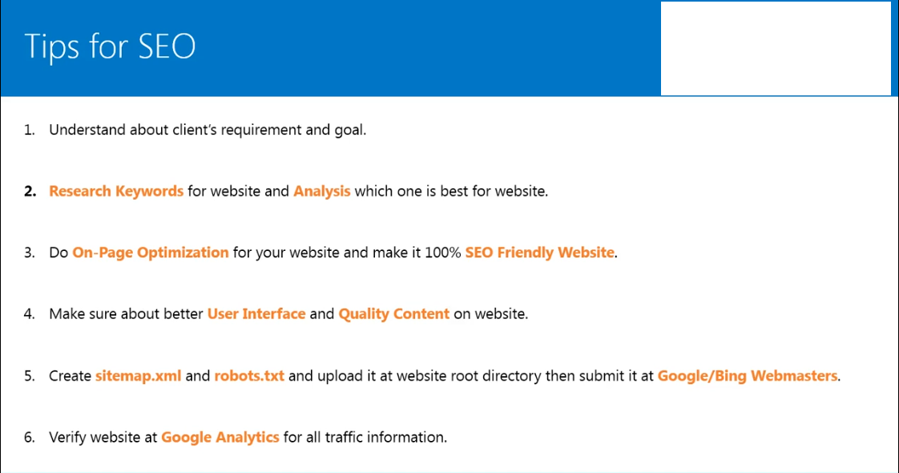
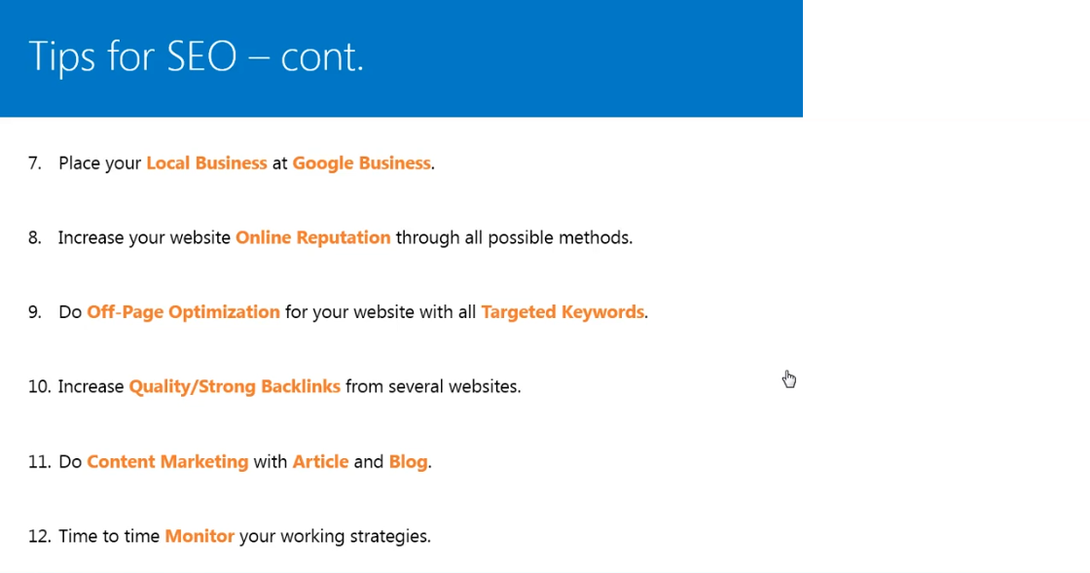
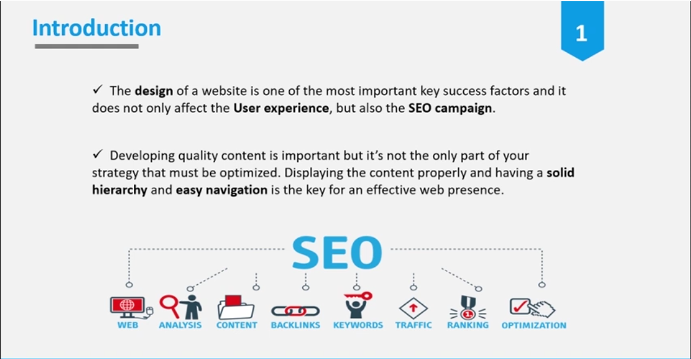
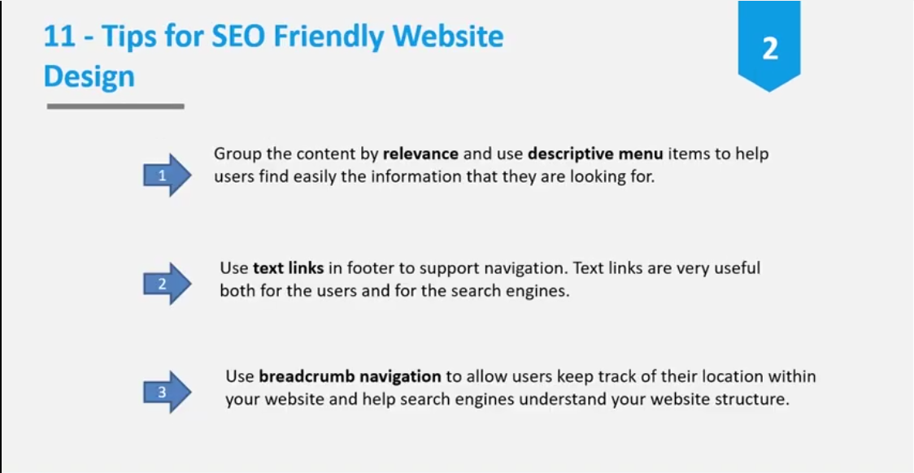
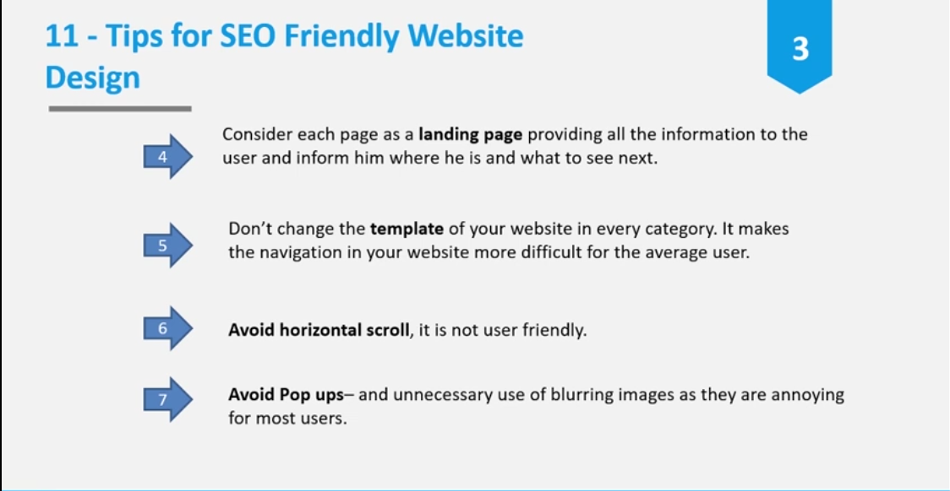
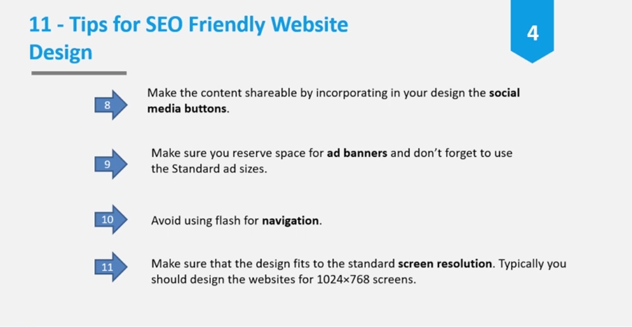
- Avoid These Mistakes
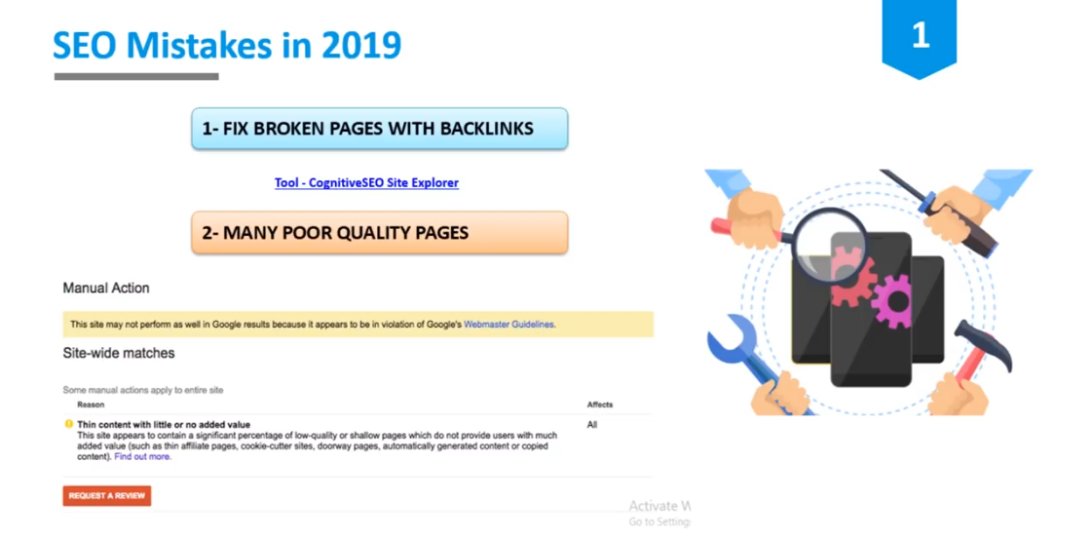
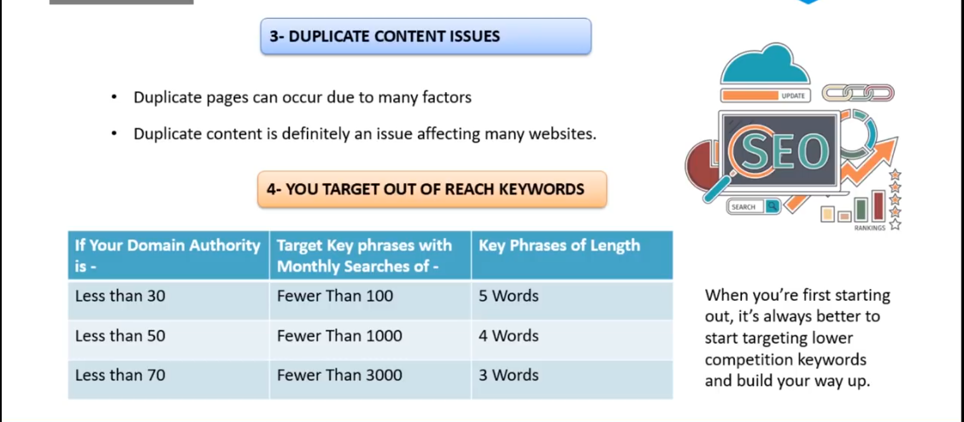
- Web Site SEO By Social Media.
- Use Social Media Management Tool to Manage Our Social Media Account.
    - Zoho.in to manage our social account.
- Google Form Used For Viewer Engagement.
- Use Pinterest For SEO Marketing.
- Mailchimp.com [ For Email Marketing ].
- Quara.com [ For SEO ]
- Media.com
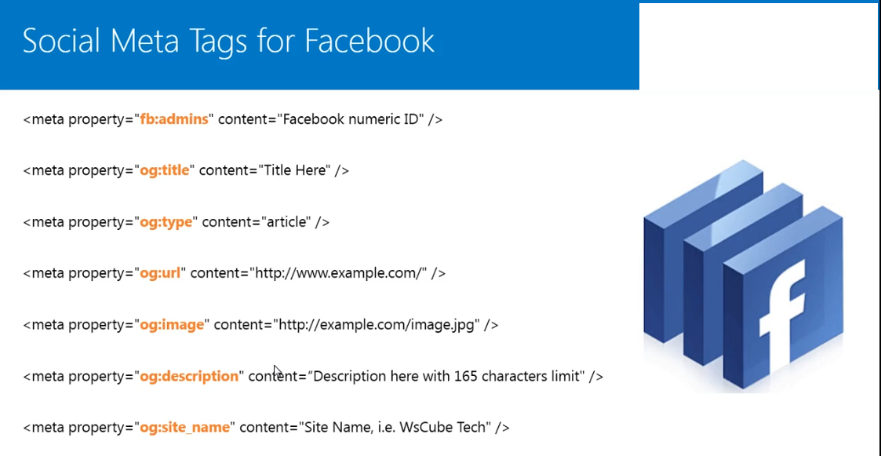
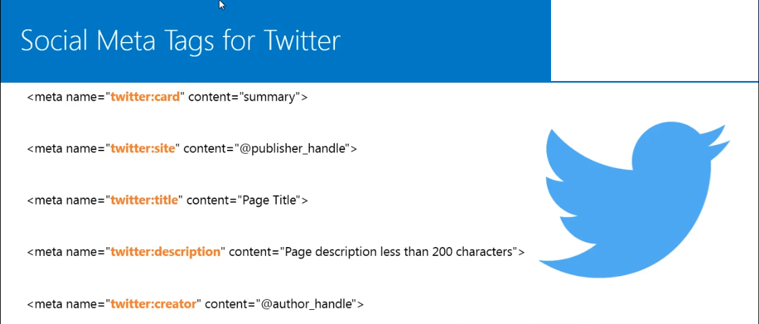
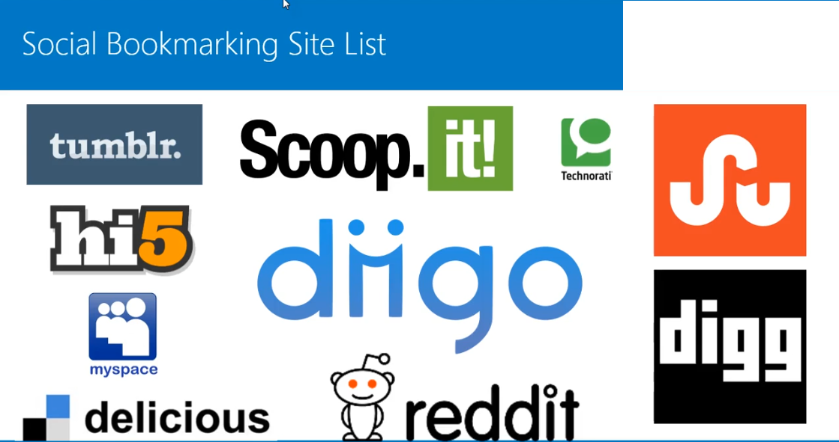

- Use Google Operator To Find Latest Update About Your Niche And Also Monitor Your Competitor.

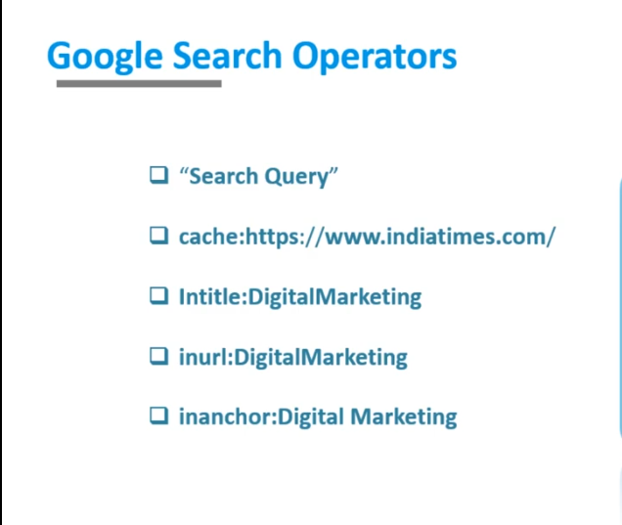
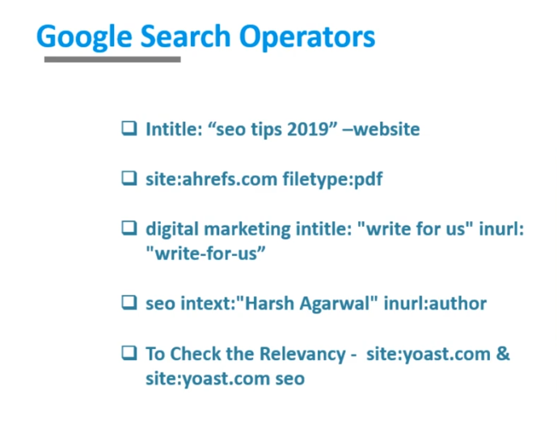

- Off Page SEO
    - Create Quality Back-Link [ Back link From Related Web Site With High DA And PA ].
    - Create Do follow And No follow Back-Link.
    - Internal Link.
    - External Link.
    - Anchor Tag [visible and highlight the main keyword].
    - 20% of back link is for our web site home not other page is high back link.
- Tools -
    - Gmass.com

SEO TOOLS TO RANK YOUR WEBSITE HIGH
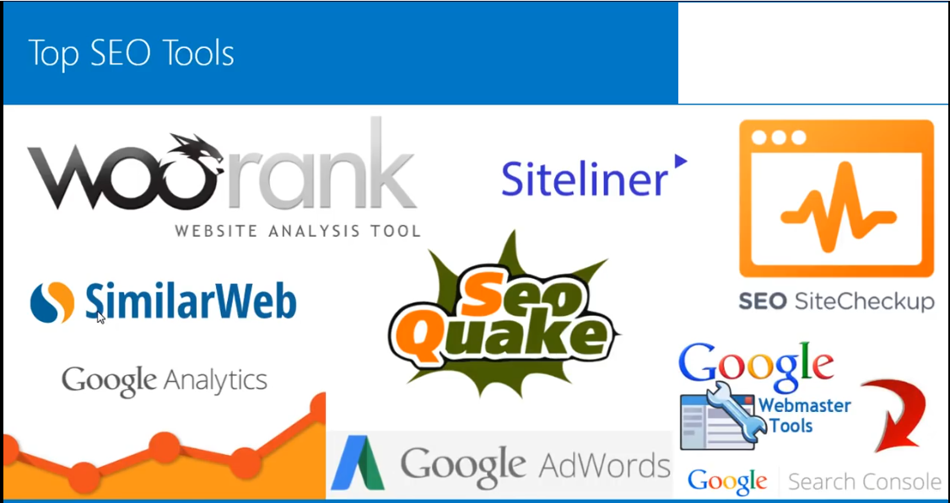
- Browser Extension
- For Chrome
  - Keyword Everywhere.
  - Check My Link [It Check The Broken Link On Our website.
  - Email - Hunter [Extract The Emails On Page.
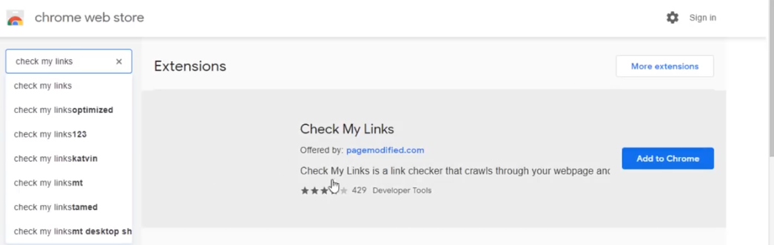
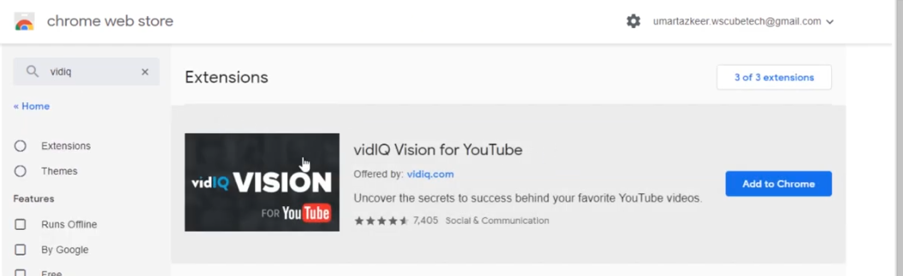
- For Fire Fox
- Tools.seobook.com .
- SEOQuake .
- WordPress -
    - Yoast SEO Plugin.
- Canva,com [for badge creation ].

